# [CC Fee Waiver and Fee Charge Request](https://confluence.global.standardchartered.com/display/CEMS/Servicing+Journey+-+CC+Fee+Waiver+and+Fee+Charge+Request)

# – Credit Card (Singapore & India)

|  |  |  |  |  |  |
| --- | --- | --- | --- | --- | --- |
| **Version** | **Date** | **Author** | **Reviewer** | **Approver** | **Version Summary** |
| 0.1 | 08/08/2017 | Gopi Lingesan |  |  |  |
| 0.2 |  | Gopi Lingesan |  |  | Card type& status included in Reward logic |
| 0.3 |  | Gopi Lingesan |  |  | Reward check updated |
| 0.4 |  | Gopi Lingesan |  |  | Eligibility flow amended |
|  |  |  |  |  |  |

***Sourcing Channel***

a) Front Line channel – SG & IN  
c) IVR - SG

***This Journey will accommodate both the below request***

* *Fee Waiver – All channels*
* *Charge – Only from Front line Channel*

***Interface System Used***

IN & SG - CCMS

***eOps Process Flow***

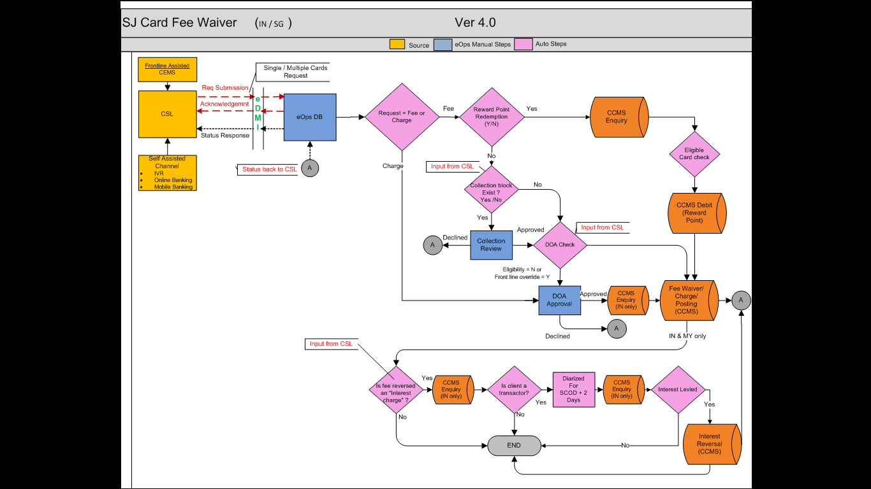

Client can use IVR channel to place the Fee waiver request for SG for annual fee and late fee or Front line channel can place the request for Fee waiver and Charge request.

For one Request, customer or front line will be allowed to select multiple cards for similar Fee typed for waiver or for a Charge.

* Charge Request can be initiated only from the Front line channel.
* CSL Will pass the flag to identify the request is for Fee Waiver or Charge.

***Fee Waiver Journey***

1. Customer or Front line will be allowed to select predefine eligible fee type or other fees from the drop down.
2. In case of the other drop down is selected, There will be a provision in the UI to capture the other fee type
3. Once the customer selected the Fee type, CSL will do the enquiry in CCMS and Reward system to identify the below three criteria and pass the request to eOps
4. NOT ELIGIBLE for fee waiver & DO NOT own enough points
5. NOT ELIGIBLE for fee waiver & OWN enough points
6. NOT ELIGIBLE for fee waiver & OWN enough points and Customer Opt out.
7. ELIGIBLE for fee waiver

**A. NOT ELIGIBLE for fee waiver & DO NOT own enough points**

1. For this type of request, Journey will be ended for front line and self assisted channel and only for IVR mode request will be passed on to eOps.
2. For Non eligible IVR request, eOps to receive the request from CSL and diarise the transaction for 1hr from the enque time and send the decline notification back to CSL and journey to be ended in eOps.

**B.NOT ELIGIBLE for fee waiver & OWN enough points**

1. For these request, CSL will pass the flag *Reward point required (Y)* along with the actual reward point to be debited for each card numbers with the corresponding fee amount to be waived.
2. eOps will skip the DOA check and Collection block checkand route the journey directly to the posting process flow.
3. eOps will do the enquiry in CCMS to find out the list of cards available for the Customer and do the check as per the below table for all the cards.

|  |  |  |  |
| --- | --- | --- | --- |
| Country | Reward Point availability | Check | Eligible |
| IN & SG | No |  | No |
| IN | Yes | Block = B, C, D, E, F, I, J, K, M, P, Q, R, S, T, Y & Z | No |
| IN | Yes | Status Not = 01 0r 02 | No |
| IN |  | Card BIN = 544438 and Type = 175/176  Card BIN = 462273and Type = 545/546 | No |
| SG | Yes | Block =ABCDEFGJKLMNOQSTUXYZ | No |
| SG | Yes | Status Not = 01 0r 02 | No |

1. For the eligible cards alone, System will check is there sufficient cumulative Reward points are available.
2. In case of insufficient reward point, reject the instruction and send the notification back to CSL and journey will be ended in eOps.
3. If there is sufficient cumulative balance available then systems to do the sort based on the expiry date and pick the card with the latest expiry date and deduct the required reward points.
4. There is no other condition to select the card for debiting reward point (other than the expiry date), if the entire reward points are available in the first card itself then same can be used.
5. Post successful confirmation from CCMS system, eOps to do the fee waiver credit to one or multiple card numbers in CCMS and successful notification to be triggered to CSL.
6. Post the notification , For SG Journey will be ended in eOps but for IN alone journey to be continued Refer

**C.NOT ELIGIBLE for fee waiver & OWN enough points and Customer Opt out.**

This type of request will not come to eOps

**D.ELIGIBLE for fee waiver**

1. CSL will pass the request to eOps with the amount to Waived for each card number
2. System will check is there any collection block exist for any of the cards and route the same to Collection reviewer queue. (Single Step in eOps)

|  |  |  |
| --- | --- | --- |
| Country | Block | Collection review |
| IN | K,Q, Z, O | Yes |
| SG | O, Y, Z, K, M, X | Yes |

1. Collection reviewer can able to either approve / Decline the request and the decision will be done manually by the user for each card level, Till the approval in place all the card in that journey will be on hold.
2. In case of multiple cards, Collection reviewer need to approve/Decline for each card level .If the decision is declined for a particular card then the journey will be ended only for that card and for the rest of the card Journey will precede further if they are approved.
3. For the approved cards , system will check for the eligibility Flag and *Front line over ride flag*
4. For the Eligibility flag Y system will not do the DOA Check, For Front line over ride flag is yes or Eligibility flag is N the system will do the DOA Check and route it to the applicable DOA Level Bucket.
5. If there is no DOA approval is required then system will do the Waiver posting in to CCMS.

IN - 8 DOA Levels (email alert is required for DOA Level 4 and above)

SG- 5 DOA Levels (No email alert)

(Refer the attachments)



1. In case of multiple cards, Request will be routed to the maximum DOA level required for that journey. DOA Approver will have the option to revised the waiver amount for each card level
2. In case of multiple cards, DOA approver need to approve/Decline for journey level (either can approve or decline for all the cards)~~each card~~ ~~level .If the decision is declined for a particular card then the journey will be ended only for that card and for the rest of the card Journey will precede further if they are approved~~.
3. For each fee amount ,Approver will have a option to revise the amount and the revised amount to be consider for the posting
4. DOA will also have the option to Refer the transaction back to Front line Referral queue (DAP applicable here also to differentiate Branch /CCC). Once the Front line submits the request flow should come back to same DOA queue.
5. For the approved card alone, system will do the Waiver posting in to CCMS.
6. Post successful posting send the First level notification mentioning for all the cards status (success / Failure) those card numbers to CSL and the journey to be ended in eOps for *SG* alone.
7. For *IN* alone for all types of Fee Waiver Request (Reward point Redemption or Eligible fee waiver), system journey to be continued as below
8. System to check the Journey pertains to Interest Charge waiver request or not and in case of *No* Journey to be ended in eOps.
9. In case of *Yes*, System to do a enquiry in CCMS to find whether any of the card in the fee waiver request is pertains to *Transactor*  Or not.
10. In case of *No,* Journey to be ended in eOps.
11. For the *Yes* Scenarios, System to Diarise the instruction for the SCOD + 2 days (for ex : If the statement date is 4 , system to diarise the instruction for 6th )
12. On the diarised date, System to do the enquiry in CCMS to pull out the statement and to check is there any similar interest charge is debited to the respective Cards
13. In case of *No*, Journey to be ended in eOps.
14. For the Yes scenario, System to waive the charge from CCMS.
15. System to Trigger the Final notification to the CSL for the applicable cards and the Journey to be ended in eOps.

***Charge Request Journey***

* 1. The entire Charge request to be routed to DOA approval queue directly without any other validation from eOps end.( For IN DOA approval is not required for Charge request)
  2. Once the DOA is approved the request, system to post a Debit entry to CCMS. Post successful confirmation from CCMS , eOps to send the notification back to CSL and the journey to be ended in eOps
  3. In case of DOA Reject the request , eOps to send the decline notification back to CSL and journey to be ended in eOps for IN and SG.

***Posting Logics***

***1. Reward Point Redemption IN & SG (CCMS)***

* 1. To find the list of Cards pertains to the Customer - eDMI service getCardList /*GetDetails*  by passing the customer Rel id to CCMS
  2. To Debit the Reward points from CCMS System - eDMI Service *Update* by passing the Card Number

***2.Waiver or Charge request IN & SG (CCMS)***

1. For Both the Fee Waiver and Charge - eDMI service *PostTransaction* to be used.
2. For IN alone, before posting Payment or non Payment mode to be identified to get the exact TC Code as below
   1. System to do a enquiry to CCMS using the eDMI service – getBalanceHistory & GetDelinquencyHistory
      1. If the card in any of the following blocks C,J, K,Q,Z and if there is any o/s amount reflecting under cash only/retail only - non payment mode TC
      2. If customer level block is H   
         Check If amount reflecting under Current and X days – payment mode TC code
      3. If amount reflecting between 30 to 210 and if there is any o/s amount reflecting under cash only/retail only - non payment mode TC.
   2. All the remaining reversals need to be passed under payment mode TC codes basis reversal category selected.
3. Post successful confirmation, eOps to Trigger the Memo Content posting to CCMS Using eDMI service *Credit Card Memo. Create Memo*

Memo Content: “Channel, SR no, fee type, amount, Transaction type”

***3.Transactor process IN (CCMS)***

1. System to do the *GetFinancialDetail* enquiry in CCMS for the entire card numbers in the request.
2. In the field *SCB_DataDelinquencyHistory* ,Check in the array value in (01-06) bucket . If the field has *B* more than 3 times then that particular card to be consider as a *transactor*.
3. For the Transactor card, In the same enquiry *GetFinancialDetail ,*check for the field *Billing Cycle* to get the Statement date
4. On the diarised date *GetTransactionHistory*  service to be used to pull the card statement to check for same interest fee charge debit done to the card.
5. If any , *PostTransaction*  service to used again to waive the Interest Fee.

***Open Points***

* Status enquiry fields
* Report Requirement finalisation
* Post transaction service eDMI

***Assumptions or Understanding***

.

***Out of Scope***